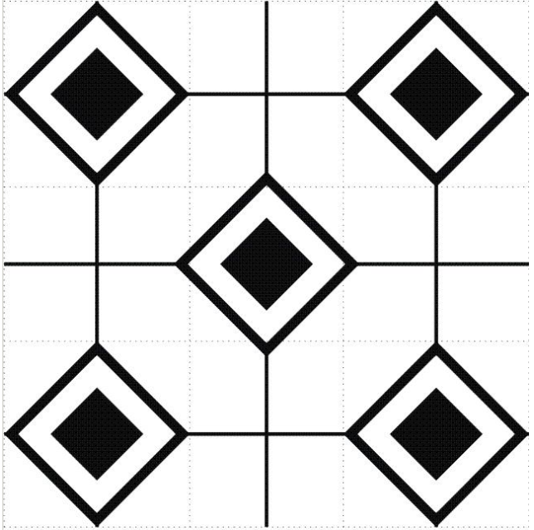
RIMEFIRE RIFLE LEAGUE TARGET Two (2) Full Name: _____________________________
Rifle @ 16.5 yards Iron / 25 yards Optic Date: _____________
Signature: _______________________________ Week Match #: _______

